- Data download: they are not handling the time rollover properly.

Time in memory is two bytes. When the time bytes rollover, it should increment the high bytes. It’s not doing this, it’s incrementing by 1 hour, which is incorrect.

For more information, check page 15 of the PPS25 Memory Gauge spec document regarding downloading data:

Byte | 0 | 1 | 2 | 3 | 4 | 5 | 6 | 7
Data | TMH | TML | PH | PM | PL | TH | TM | TL

Elapsed Time (seconds) = (TMH × 256) + TML
Note: time is 2 bytes but rolls-over on overflow (ie 0xFFFF to 0x0000). The number of rollovers must be retained and included in the time calculation equation. ie (RollOvers × 65536 + ElapsedTime).

I’ve outline the difference below. See the highlighted sections. You can see that when the time bytes go from 0xFFFF to 0x0000, time should be 0x010000. In other words, for each time rollover they should be adding 65536 seconds, but it seems like they are instead adding 3600 seconds (1 hour).

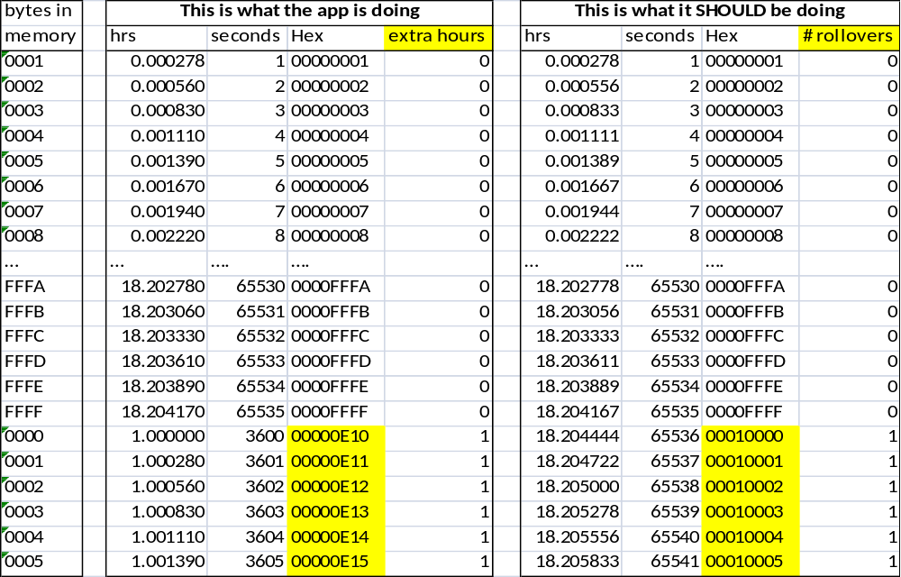
The equation should be something like this:
new_time_in_seconds = newtime + (rollovers * 0x010000)

Example: if there have been 20 rollovers, then a time of 0x0003 would be 0x00140003.

Time_in_seconds = 0x0003 + (0x14 * 0x10000) == 0x00140003 seconds
or
Time_in_seconds = 3 + (20 * 65536) == 1310723 seconds

- Erase Jobs: In the Basic Design requirements (page 9), it mentions the need for a warning before erasing jobs. If the user presses the Erase All Jobs button, it should ask the user for confirmation before proceeding. The current version does not do this. If I press the Erase All Jobs button it just starts erasing, which is incredibly dangerous because a user could accidentally hit this and lose all their data with no way to recover it.

- Erase Jobs: It keeps stalling while erasing jobs. It gets part way into the erase before stopping, and it appears to never recover, it just hangs forever. I don’t see any patterns, the progress is different each time it fails. I suggest, if an EraseBlock command fails to get a response, resend it. If it still fails, stop the erase and inform the user that something went wrong.

The gauge appears to still be fine when this happens (if I exit the app and go back in it can communicate okay). If I erase using PC software, it succeeds without any trouble. It’s only an issue with the app.

It got stuck like this and I left it for a half hour, nothing happened
